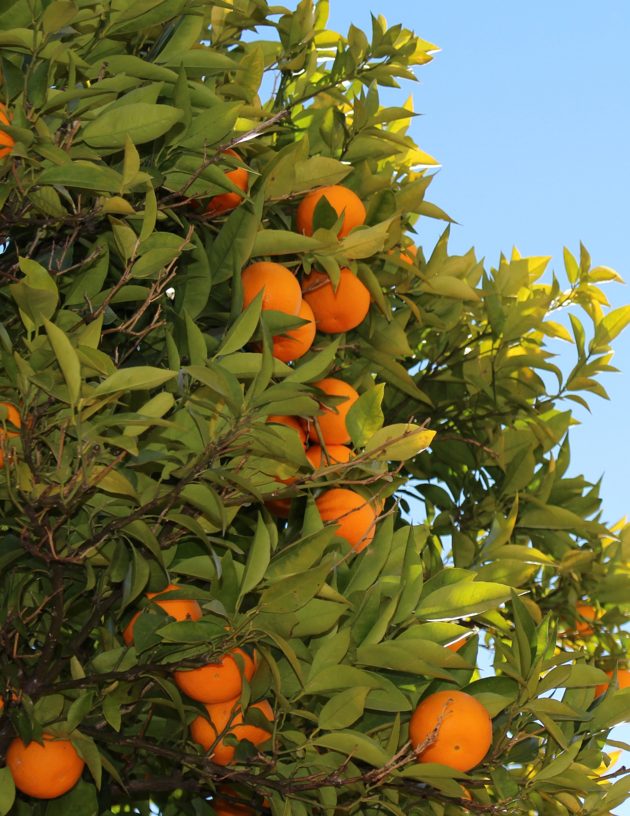
MARCH 2015

GUIDE TO DRAFTING A FOOD BANK
NUTRITION POLICY
PREPARED BY UC BERKELEY CENTER FOR WEIGHT AND HEALTH

AUTHORS
Karen Webb, PhD, MPH, Elizabeth Campbell, MA, RD, Michelle Ross, MPH and Laura Vollmer, BA, University of California, Berkeley, Center for Weight and Health

ACKNOWLEDGEMENTS

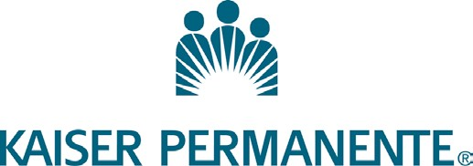
This resource was developed for the project, ‘Nutrition Focused Food Banking’, funded by Kaiser Permanente.
We thank Elisa Wong and Andrea Azuma, Kaiser Permanente, for their collaboration and support on the project.
A key partner in the project is MAZON: A Jewish Response to Hunger. Parts of this guide were adapted from resources developed for Healthy Options, Healthy Meals™, a partnership project with MAZON and UC Berkeley Center for Weight and Health.
We thank the following individuals for their review and helpful comments on this resource.

Marla Feldman, Program Director of Healthy Options, Healthy Meals™, MAZON: A Jewish Response to Hunger
Kenneth Hecht, JD, Director of Policy, Nutrition Policy Institute, University of California

Heather Hudson, MA, RD, Director of Food Sourcing & Nutrition, Food Bank of Central New York
Michelle Berger Marshall, MS, RD, Director of Nutrition, Feeding America

Rita Mitchell, RDN, Nutrition Research, Associate University of California, Berkeley Center for Weight and Health
Bethany Slater, PhD candidate in Public Administration, University of Albany Tom Slater, Former Executive Director, Food Bank of Central New York
Hilary Seligman, MD, MAS, Associate Professor of Medicine and of Epidemiology and Biostatistics Division of General Internal Medicine, University of California San Francisco, Core Faculty, Center for Vulnerable Populations at San Francisco General Hospital

Copyright © 2015 The Regents of the University of California, All Rights Reserved UC Berkeley Center for Weight and Health

CONTENTS

INTRODUCTION 4
SECTIONS TO BE INCLUDED IN A FOOD BANK NUTRITION POLICY 4
- Statement Of Purpose 4
- Policy Rationale And Benefits 4
- Food Inventory Sources Covered By The Policy 5
- ‘Foods To Encourage’ Covered By The Policy 6
- Optional: Foods To Reduce Covered By The Policy 7
- Foods to Prioritize 8
- Brief Overview Of Policy Implementation And Review 8
APPENDICES 10
  - Example Food Bank Nutrition Policy 12
  - Supplement To Example Policy 15
B1. Example Section On Foods To Reduce 15
B2. Example Section On Foods Not Covered By This Policy 16
  - Nutrition Policy Checklist For Food Banks 17
  - Feeding America’s ‘Detailed Foods To Encourage (F2E)’ Framework 19

INTRODUCTION
This guide is a tool for working groups to use in drafting food bank nutrition policies for submission to the Board of Directors, which usually sets policy for food banks. The guide is intended for use as part of a training package on all of the steps involved in developing a food bank nutrition policy. It provides tips on drafting the various sections of a policy document. Throughout the process of policy development, the working group will need to seek and address input from stakeholder groups, so that the policy will ultimately have wide support.
An example ‘model’ food bank nutrition policy is included in Appendix A with supplemental policy language in Appendix
- It can be borrowed, adapted or used “as is” for any food bank nutrition policy. A checklist is also included in Appendix C for use by the nutrition policy working group and other stakeholders when reviewing the draft policy.

SECTIONS TO BE INCLUDED IN A FOOD BANK NUTRITION POLICY

STATEMENT OF PURPOSE
The main purpose of any policy is an official statement of organizational intent, a guide to action, and a set of specific details about how the organization plans to conduct its core business in line with its mission, vision and goals.
It is a written tool that ensures clear communication with partner agencies and food suppliers about the food bank’s intentions and decision-making. It provides a durable, on-going record for use when new food bank staff or managers come on board.

The main purpose of a written food bank nutrition policy is to guide food procurement decisions of the food bank and promote consistent decision-making to acquire more healthful foods for distribution.
Other nutrition-related activities and practices, such as nutrition education, may be included in the policy, but should serve to complement its main focus: to improve the nutrition quality of the foods and beverages to be distributed.
An example statement of purpose is included in the example policy located in Appendix A.

POLICY RATIONALE AND BENEFITS
A brief but clear rationale spells out the main benefits of having
a policy, giving a good grounding to all stakeholders about the food bank’s position on the importance of having a nutrition policy. It explains the benefits internally for the food bank, and externally for its clients, food suppliers and the wider community it serves.
The rationale is an important section of the policy. A convincing rationale helps to obtain support from senior management
and the Board of Directors. Donors and other food suppliers, too, may be more amenable to changing the foods they provide, when the food bank links the new direction with their aspirations for making a positive difference in the community’s health and well-being.
Examples of key internal benefits for the food bank to include in a nutrition policy rationale are that the policy:
    - Conveys a commitment to change on the part of the leaders of the organization.
    - Gives staff permission to work on nutrition quality of foods during their work time and in the course of their duties.
    - Gives staff permission to change sourcing practices in line with the policy.
    - Communicates clearly with all staff and mangers exactly which types of foods and beverages are encouraged and prioritized to promote consistent decisions about food procurement.
    - Provides ‘institutional memory’ about the commitment to provide healthful foods, through changes of management and staff.
    - Provides a basis for modifications to strategic and operational plans, policy and procedures manuals, job descriptions and other management documents.
BENEFITS OF A FOOD BANK NUTRITION POLICY

Clear written guide for consistent staff decisions about food procurement
- Organizational commitment to client nutrition and health
- Demonstrates good corporate citizenship and models responsible behavior
- An official tool for communication with donors and other suppliers

      - Provides a kind of a contract to which staff, management and the Board are accountable to all stakeholders. It provides a basis for reporting on how the food bank is achieving the policy goals.
These benefits are worth spelling out so food bankers know how the policy can help them.
Examples of external benefits to food banks of having a nutrition policy include:
      - Demonstrates to the community that the food bank is a responsible ‘food provider’, modeling by supplying healthful foods.
      - Conveys responsiveness to client health and client preferences and generates client confidence that their needs and views have been taken into consideration.
      - Informs donors and other suppliers of the food bank intent and of the details of foods sought.
      - Provides a tool for communication and encouragement of pantries and other agencies affiliated with the food bank to follow suit and improve the nutritional quality of the foods it supplies to clients including those they purchase or acquire from local donations.

FOOD INVENTORY SOURCES COVERED BY THE POLICY
A comprehensive food bank nutrition policy covers all of the three main sources of foods and beverage inventory including:
- Donated foods

- Government supplied foods
(e.g., TEFAP, bonus commodities)

- Foods purchased by the food bank

Recent estimates indicate that for most food banks across the country, the majority of inventory (about 66%) comes from donations, about 20% from government commodities,
with a low percentage (usually about 14%) that the food banks purchases, usually wholesale.1
A comprehensive policy covering all sources is the best way to increase the supply of healthful foods for clients. But sometimes it is only feasible to start with just one of the sources of food inventory because stakeholders may not support a comprehensive policy initially. For example, developing a policy for purchased foods is a good place to
start since food banks have control over their own purchasing decisions and less control over what foods are donated or available from government sources.

1 Feeding America. 2013. FY2013 – POU23 Total Product Distribution in Pounds. Chicago, IL: www.hungernet.org. Accessed November 19, 2013.

“We had an informal ‘policy’ where we all kind of had the idea of sourcing more nutritious foods. But when we went around and talked to staff,
we found that everyone had a different idea about what that meant. We decided we needed a formal written policy.”
–Healthy Options, Healthy Meals 2012

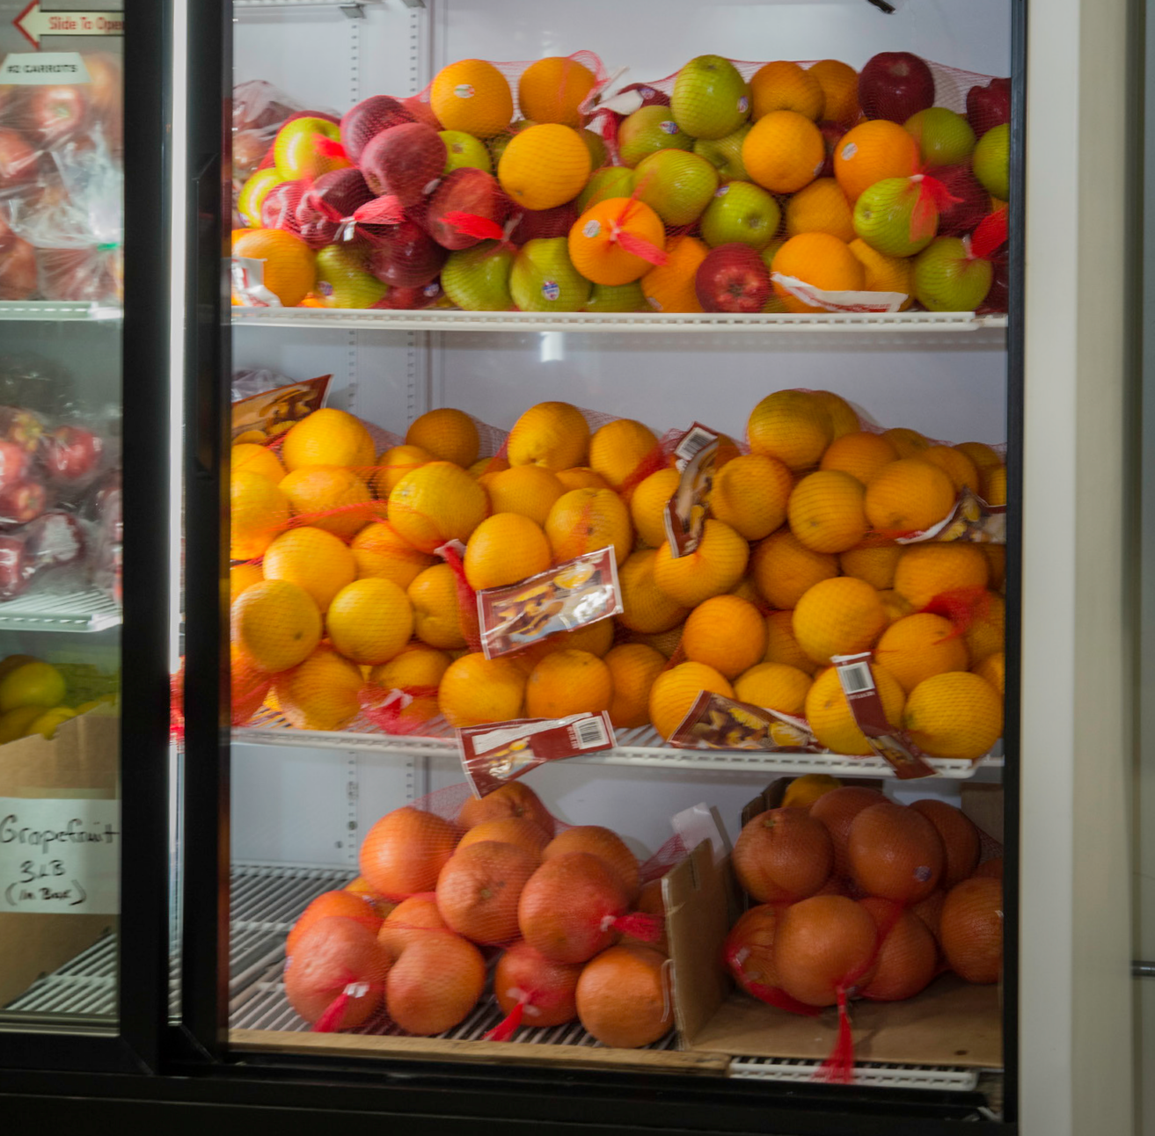
AUTOMATIC ‘FOODS TO ENCOURAGE’ INCLUDE:
- Fruit (nothing added)
- Vegetables (nothing added)
- 100% whole grain (e.g. rolled oats, barley or wild rice)
- Unflavored/Unsweetened low-fat (1%) or skim/non-fat milk or yogurt
- Flavored skim/non-fat milk or yogurt
- Unsweetened milk substitutes (e.g.soy milk, almond milk)
- Protein foods including:
  - Eggs
  - Nuts, seeds, beans and lentils if nothing added (e.g. sodium)
- Plain water
- 100% Juice
- For some food categories nutrition criteria are included to identify more healthful varieties. See the Appendix D for a list of ‘Detailed Foods to Encourage’.
PHOTO CREDIT: 20140910-FNS-RBN-0139 BY USDA LICENSED UNDER CC 2.0

‘FOODS TO ENCOURAGE’ COVERED BY THE POLICY
The policy must be specific enough to inform and guide decisions and actions that lead to the policy goals. Anyone reading it should know exactly what foods are to be procured and distributed.
The types of foods recommended in the Dietary Guidelines for Americans,2 and specified in Feeding America’s framework- ‘Foods to Encourage (F2E)’- should be included in the policy.
These food groups include fruits, vegetables, whole grains, low- fat dairy foods, lean protein foods, plain water and 100% juice. A summary of F2E is included in the Appendix D.
Feeding America’s ‘Detailed Foods to Encourage’ framework specifies nutrition criteria for distinguishing between more and less healthful foods in each of these categories. Some foods are clearly F2E; for example, all fresh fruits and vegetables, so nutrition criteria are not needed for these. The foods listed in the example policy are aligned with this framework.
2 USDA. (2010). Dietary Guidelines for Americans. US Department of Agriculture and US Department of Health and Human Service.

These criteria were developed to identify foods in each category that are nutritionally preferable to others; in other words, not all meats, not all grains, and not all dairy foods are the most healthful.
Foods that are nutritionally superior to others are those that contain more vitamins, minerals, and/or fiber without a lot of added fat, sugar or sodium.
There are at least three main uses of a nutrition criteria in a policy. They help:
- Procurement staff identify products to be ordered that do (and do not) align with the policy,
- Receiving staff identify and document basic nutrition details about products received, and
- Inventory monitoring staff to create regular reports that summarize trends in each group of ‘Foods to Encourage’ and if relevant, foods to reduce.
In order to use nutrition criteria to evaluate a food or to document the nutrition details on receiving cards, information

on the nutrition labels of processed products needs to be reviewed. Various options exist for simplifying and streamlining the process of describing and classifying foods for ordering and monitoring policy implementation, such as:
    - Creating electronic ‘item cards’ with the nutrition information for common food products received
    - Creating a ‘catalogue listing’ of product nutrition information by brand, and whether the products meet the policy nutrition criteria.
Subsequent resources relevant to policy implementation will address some strategies used by food banks that have developed nutrition policies.
If, after discussion, stakeholders do not endorse a comprehensive policy, (i.e., one that applies to all F2E, and/or all sources of inventory) a good starter policy might cover the less controversial food groups, such as fruits and vegetables. The policy can be reviewed after a period of time, to expand it to other food groups and sources, once stakeholders are comfortable with the initial implementation of the ‘starter’ policy.
A recent case study of the inventory of selected food banks in California pointed to a need to consider improvements within the groups of F2E and to prioritize these.
While fresh produce donations increased, potatoes and onions comprised the majority of the fresh vegetables procured. This suggested an opportunity to diversify the types of vegetable donations and purchases to incorporate more nutrient-dense varieties.3 More colorful vegetables such as dark green, red and orange varieties are more ‘nutrient-dense’; that is high in vitamins, minerals and fiber and therefore will contribute to improved diet quality of clients.2
In addition, surveys of client preferences for charitable food assistance showed that healthful fresh foods were ranked as most preferred, headed by fresh vegetables, fresh meat, poultry,

- Ross M, Campbell E, Webb KL. Recent trends in the nutritional quality of food and beverage inventory of food banks; case studies of six California food banks. J Hunger Environ Nutr. 2013;8(3):294–309.
fish and fresh fruits.4, 5, 6 These foods were preferred because they are more healthful, appealing and because they cost more to purchase than other foods. Thus, such foods from the pantry help to increase household access to healthful basic foods.

- OPTIONAL:

FOODS TO REDUCE COVERED BY THE POLICY
The Dietary Guidelines for Americans specifies foods and food components to limit in the diet, including discretionary added sugars and solid fats that supply considerable calories and few nutrients.2 The Guidelines advise that these foods should be limited to small amounts occasionally. Commonly consumed sources of added sugars and fats in the American diet include sugar-sweetened beverages (SSBs), sweet snacks and desserts (such as candy, cakes, cookies) and savory snack foods (such as chips).
Foods in these categories tend to be high in calories and low in nutrients. An increasing number of food providers, such as
schools, hospitals and workplaces have introduced guidelines to limit or exclude these foods to protect the health and prevent excess weight gain among the populations they serve.
Americans consume, on average, about 170 calories daily (8% of total calories) from SSBs, with soda being the largest contributor to these calories. Fruit drinks, sweetened tea and coffee, energy/ sport drinks and flavored milks are other main sources.7
Even among food banks that discourage SSBs and have a low

- Campbell E, Hudson H, Webb K, Crawford PB. Food preferences of users of the emergency food system. J Hunger Environ Nutr. 2011; 6(2):179–187.
- Webb K, Campbell E, Ross M, Crawford P. Improving the Nutritional Quality of Foods Distributed to Lower-Income Families Through Emergency Food Services: A Study of Nutrition-Related Policies and Practices of Food Banks and Food Pantries. Available at: http://cwh.berkeley.edu/sites/default/files/primary_pdfs/Improving_the_Nutritional_ Quality_of_Foods_Distributed_to_Lower-Income_Families_through_Emergency_Food_ Services_6.12_0.pdf. Accessed January 26, 2015.
- Weinfield NS, Mills G, Borger C, Gearing M, Macaluso T, Montaquila J, Zedlewski
S. Hunger in America 2014, National Report Prepared for Feeding America. Available at: http://www.resourcelibrary.gcyf.org/sites/gcyf.org/files/resources/2014/hunger-in- america-2014-full-report.pdf. Accessed January 26, 2015.
- Miller PE, McKinnon RA, Krebs-Smith SM, Subar AF, Chriqui J, Kahle, L, Reedy, J. Sugar-Sweetened Beverage Consumption in the US: Novel Assessment Methodology. American journal of preventive medicine. 2013; 45(4):416-421.

inventory of them, these beverages still contribute surprisingly high amounts of calories to client diets. In one food bank we studied with a low average annual inventory of SSBs, these drinks contributed over 1 billion calories annually to the low income households they serve.3
Experts in nutrition and public health agree that effective programs and policies most likely to improve peoples diets involve making healthful choices more easily available and at the same time making less healthful choices less readily available.8,9
Clients give a low ranking to foods high in sugar and fats among their preferences for foods from the pantry. In at least three studies, food that ranked the lowest were SSBs, salty snacks and sweet desserts.4-6
An example of the wording which can be used in a section on “Foods to Reduce” is shown in the supplemental example policy.

FOODS TO PRIORITIZE
Priority foods are those on the list that the food bank highlights as most important. They should be the focus of the first efforts after the policy is launched, although all of the groups of F2E should be included in a comprehensive nutrition policy.
The value of having a section to identify the priority foods is that it:
  - Draws attention to a few food groups where food bank staff and management can focus their efforts,
  - Maximizes chances of success by not spreading effort too thinly, and
  - Identifies a small number of categories for improving inventory documentation and reporting.
Priorities can be set based on many different criteria such as:

  - Those healthful foods where the food bank is already focusing effort and has more work to do,
  - Those foods most wanted by clients (i.e., fresh fruits and vegetables, dairy, lean meats) and those least wanted (i.e., sugar sweetened beverages and snacks),
  - Those foods that would contribute to improvements in client diets and health, such as clients with diabetes. For example, prioritizing an increase of fruits and vegetables as well as reducing sweet beverages and snacks.
  - Those foods where inventory trends suggest food procurement is heading in the wrong direction in relation to the policy, such as decreasing or leveling off of vegetables, or increasing snack foods.
Increasing fruits and vegetables, particularly fresh forms that have client appeal and nutrient dense varieties could easily be a clear priority for most food banks. We advise food banks to include all groups of ‘Foods to Encourage’ in the main policy, and select one or two groups as priorities for an initial focus.
Priority foods highlighted in the policy can be further described in operational plans, strategic plans and other documents that guide the food banks operations and reporting.
There is an opportunity to update this section each time the policy is reviewed (e.g., every 6-12 months) without modifying the main policy.

- Brownell, KD & Horgen, KB. Food fight: The inside story of the food industry, America’s obesity crisis, and what we can do about it. Chicago: Contemporary Books. 2004.
- Gittelsohn J. Interventions in small food stores to change the food environment, improve diet, and reduce risk of chronic disease. Preventing chronic disease, 2012; 9.

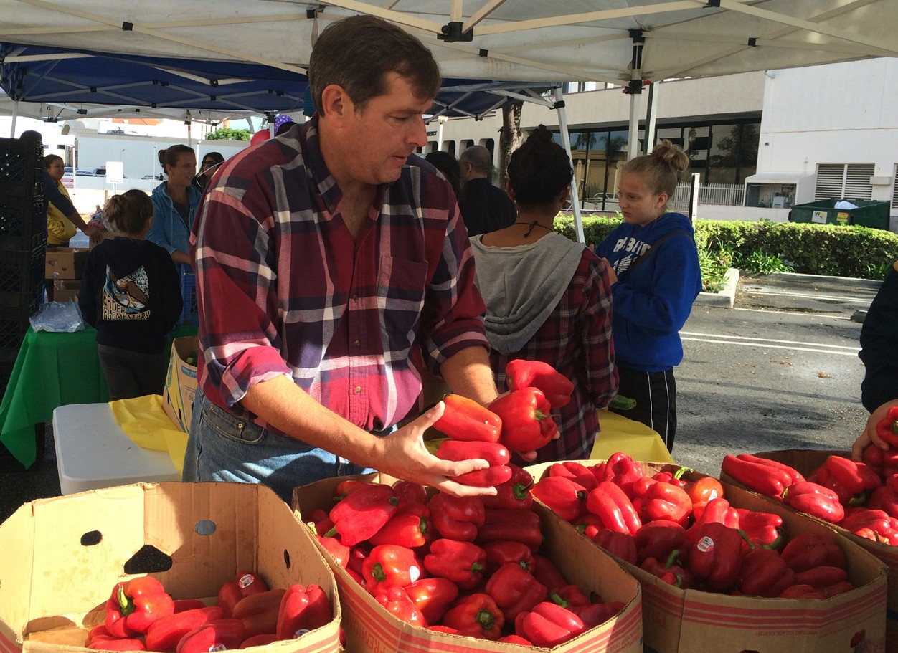
One food bank group told us,
“The food bank staff was more open to conversations and improvements after having worked with the initial policy.
Including a review date in the policy helped provide an official opportunity to review staff experience with the policy and strengthen it, after initial caution and resistance.”
PHOTO CREDIT: UCI MOBILE FOOD PANTRY NOV 1, 2014 BY UC IRVINE LICENSED BY CC 2.0

BRIEF OVERVIEW OF POLICY IMPLEMENTATION AND REVIEW
Including information about the implementation of the policy indicates a commitment by the food bank to act on the policy.
The following information is useful for all stakeholders to receive about the food bank’s intentions:
  - When the policy will take effect including an official date and when will it be added to the food bank’s official policy and procedures manual.
  - When the policy will be disseminated and communicated to stakeholder groups within and external to the food bank and which staff position is responsible to oversee this plan.
  - Who has signatory authority to approve the policy (the Board of Directors, the ED/CEO).
  - Which staff member(s) should be contacted with questions about the policy.
  - Which staff positions and departments are responsible for the implementation of different aspects of the policy.
- For example, the procurement staff in the operations department is responsible for sourcing priority foods; the receiving and inventory staff in the operations department is responsible to develop and implement new documentation procedures on priority foods, etc.
  - When and how will training be provided to ensure staff has the skills needed to implement and track the policy.
  - How progress towards policy goals will be reported (e.g., using information from improved inventory records on particular types of ‘Foods to Encourage’).
  - When the policy will be reviewed and updated.

Food banks we have worked with indicated the benefits of having an official review date to review perceptions of stakeholders regarding how well the policy is being implemented. During policy reviews the food bank can:
  - Expand the policy if a the initial policy was limited to one source or one type of food to start with, and/or
  - Keep working towards improved documentation of the types of foods coming in, so progress can be better monitored.
IMPLEMENTATION DETAILS
This section of a nutrition policy includes:
- When the policy will be approved and when it will take effect
- When it will be disseminated
- Who has approval authority
- Who to contact with questions
- What departments are responsible
- When training will occur
- When policy review and update occur

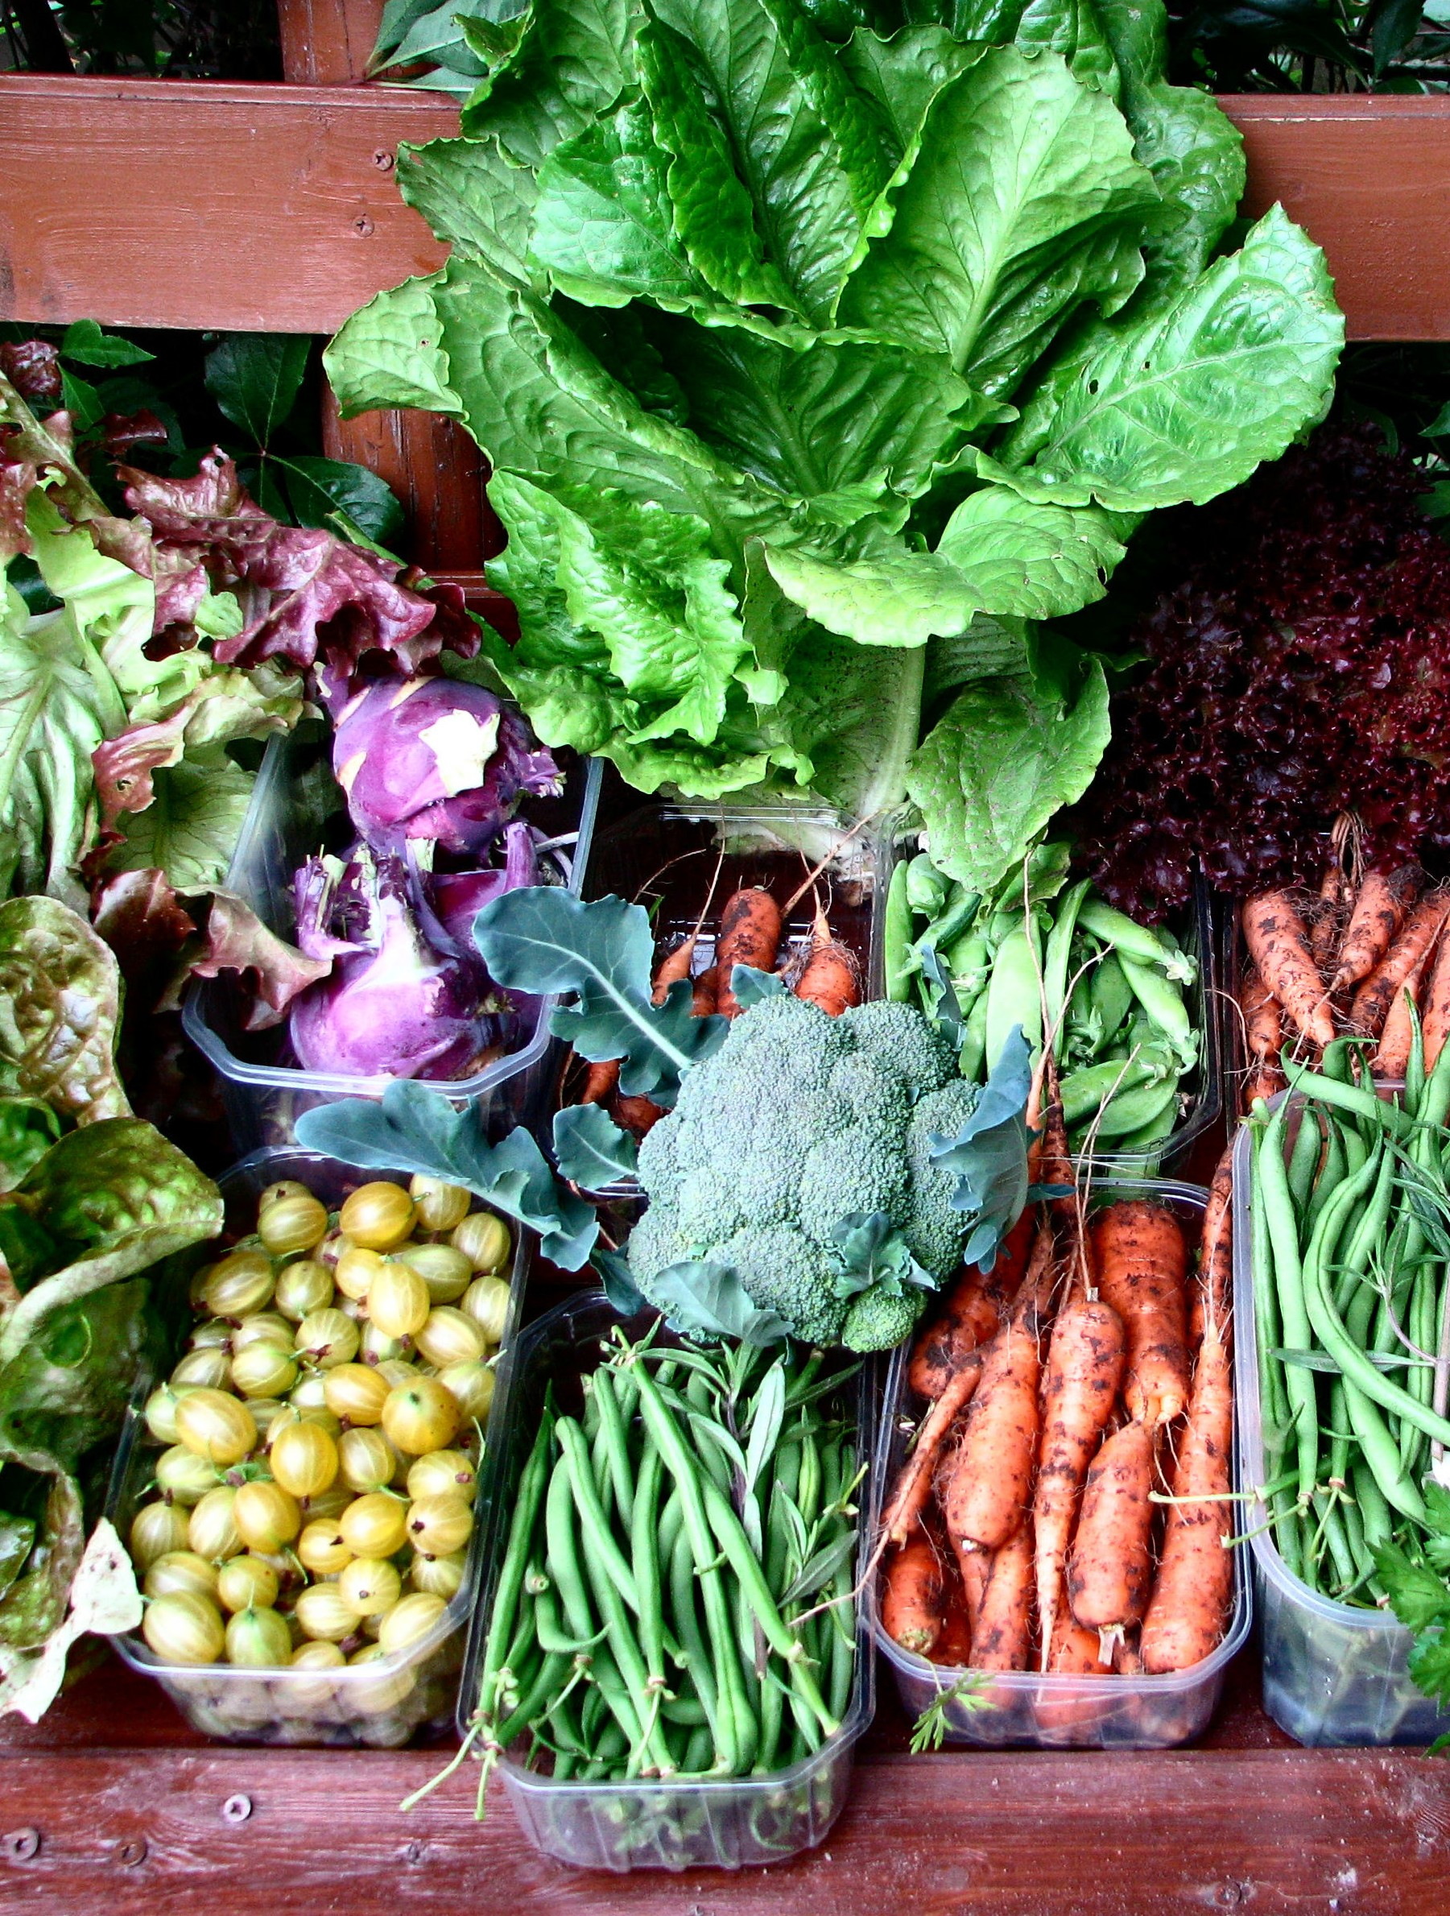

APPENDICES

DAILY VEGETABLE HARVEST BY ANDREAS IS LICENSED UNDER CC 2.0

APPENDIX A EXAMPLE FOOD BANK NUTRITION POLICY

EXAMPLE FOOD BANK NUTRITION POLICY FOR FOOD PROCUREMENT
Using Feeding America’s framework ‘Detailed Foods to Encourage’ to guide procurement of purchased, donated and government foods
PREPARED BY: NUTRITION POLICY WORKING GROUP ON BEHALF OF THE BOARD OF DIRECTORS OF [NAME OF FOOD BANK]

AUTHORS OF THE EXAMPLE POLICY: KAREN WEBB, ELIZABETH CAMPBELL, MICHELLE ROSS & LAURA VOLLMER (LIST MEMBERS OF WORKING GROUP AS AUTHORS FOR YOUR POLICY)

APPENDIX A EXAMPLE FOOD BANK NUTRITION POLICY

POLICY TITLE: NUTRITION POLICY FOR FOOD PROCUREMENT FOR [FOOD BANK NAME]

- STATEMENT OF PURPOSE
The purpose of this nutrition policy is to guide food bank decisions about the foods to acquire and distribute that will contribute to more healthful diets of our clients, as well as alleviating hunger and food insecurity.
Our nutrition policy communicates to clients, affiliated local pantries and other agencies, donors, government programs and the community-at-large that we are committed to providing healthful foods to clients.

- POLICY RATIONALE AND BENEFITS
[Food Bank Name] has a history of service to the community, supplying foods to help families in hard times. In recent years, the food bank has become concerned about the increasing rates of diabetes, obesity, high blood pressure and other serious diet-related diseases and conditions in the community.10
Our food bank has a strong commitment to providing healthful foods to clients. We are working with donors and government programs to make this happen.
We want our clients to know that their health and preferences for more healthful foods11, 12, 13 are among our highest considerations in acquiring food.
We recognize the increasing role that food banks play in providing healthful foods to community members in need. Our policy to procure and distribute foods of high nutritional quality demonstrates to the community that we take our role and responsibility seriously.
This policy ensures that our organizational commitment to distributing healthful foods is a part of our institutional memory and provides staff with a basis for clear and consistent decision making about the types of foods and beverages they should procure, encourage and prioritize in their work. The policy also serves as a tool for management and accountability on moving towards the provision of more healthful foods.

FOOD INVENTORY SOURCES COVERED BY THIS POLICY
This policy applies to all foods acquired by the food bank including:

  - Foods and beverages donated by food manufacturers, distributors, retailers, organizations, producers and community members,
  - Foods and beverages obtained from government programs, and

  - Foods and beverages purchased by the food bank.

- Seligman, HK, Laraia, BA, Kushel MB. Food insecurity is associated with chronic disease among low-income NHANES participants. The Journal of Nutrition, 2010: 140.2: 304-310. 11 Campbell E, Hudson H, Webb K, Crawford PB. Food preferences of users of the emergency food system. J Hunger Environ Nutr. 2011;6(2):179–187.
- Webb K, Campbell E, Ross M, Crawford P. Improving the Nutritional Quality of Foods Distributed to Lower-Income Families Through Emergency Food Services: A Study of Nutrition- Related Policies and Practices of Food Banks and Food Pantries. Available at: http://cwh.berkeley.edu/sites/default/files/primary_pdfs/Improving_the_Nutritional_Quality_of_Foods_ Distributed_to_Lower-Income_Families_through_Emergency_Food_Services_6.12_0.pdf. Accessed January 26, 2015.
- Weinfield NS, Mills G, Borger C, Gearing M, Macaluso T, Montaquila J, Zedlewski S. Hunger in America 2014, National Report Prepared for Feeding America. Available at: http://www.resourcelibrary.gcyf.org/sites/gcyf.org/files/resources/2014/hunger-inamerica-2014-full-report.pdf. Accessed January 26, 2015.

APPENDIX A EXAMPLE FOOD BANK NUTRITION POLICY

- HEALTHFUL FOODS TO ENCOURAGE AT [FOOD BANK NAME]- COVERED BY THIS POLICY
This policy is based on the Dietary Guidelines for Americans, Feeding America’s ‘Foods to Encourage’ (F2E)14, framework and research evidence about client food preferences.11-13 In accordance with this nutrition policy, we aim to actively seek, procure and distribute the following foods when appropriate and possible:
- FRUIT AND VEGETABLES – including:
  - Fresh produce, including more colorful varieties, because they are rich in nutrients and low in calories.
Examples include but are not limited to fresh carrots, cabbage, broccoli, spinach, Brussels sprouts, bell peppers and berries.
  - Frozen fruits and vegetables packed without syrup or sauces.
  - Fruits canned–in water, 100% juice, or “lite” syrup
F2E guidelines: ≤ 12g total sugar/serving with no partially hydrogenated oil in ingredient list
  - Vegetables canned–with no added salt or reduced sodium
F2E guidelines: ≤230mg sodium/serving with no partially hydrogenated oil in ingredient list

- WHOLE GRAIN AND WHOLE GRAIN-RICH FOODS – particularly:
  - 100% whole grains such as rolled oats, barley, wild rice and brown rice
  - Whole grain-rich bread, pasta and tortillas that contain whole grain as first ingredient
F2E guidelines: ≤2g saturated fat/serving, 0g of trans-fat, ≤230mg of sodium/serving, ≤10g total sugar/serving,
>10% daily value RACCs (reference amounts customarily consumed) of fiber or >2.5 g fiber/serving
  - Whole grain-rich cereals that contain whole grain as first ingredient
F2E guidelines: ≤2g saturated fat/serving, 0g of trans-fat, ≤230mg of sodium/serving, ≤12g total sugar/serving, >3 g fiber/serving

DAIRY FOODS: LOW-FAT DAIRY OR DAIRY SUBSTITUTES – including:
  - Plain milk and yogurt: Low-fat (1%) or skim/non-fat milk and yogurt, unflavored/unsweetened
  - Milk substitutes–Unsweetened milk substitutes (e.g., soy milk, almond milk)

Flavored milk or milk substitutes
F2E guidelines: ≤3g saturated fat/serving, 0g of trans-fat, ≤480mg of sodium/serving, ≤22g total sugar/serving
  - Flavored yogurt: Flavored low-fat (1%) or skim/non-fat yogurt
F2E guidelines: ≤3g saturated fat/serving, 0g of trans-fat, ≤480mg of sodium/serving, ≤30g total sugar/serving
  - Cheese: Reduced fat or low-fat
F2E guidelines: ≤3g saturated fat/serving, 0g of trans-fat, ≤480mg of sodium/serving

- LEAN PROTEIN FOODS – including:
  - Meat, poultry, seafood and beans–low-fat, lower sodium
F2E guidelines: <4.5g of saturated fat/serving, 0g of trans-fat, ≤480mg of sodium/serving,

Eggs
  - Nuts and seeds (no added salt), including spreads such as peanut butter
F2E guidelines: 0g of trans-fat, ≤230mg of sodium/serving, <4g total sugar/2T or 1 oz, no partially hydrogenated oil in ingredient list
  - Beans and lentils (if canned, no added salt)

- F2E guidelines are shown where they are based on detailed criteria for nutrients or other food components.

APPENDIX A EXAMPLE FOOD BANK NUTRITION POLICY

OPTIONAL: FOODS TO REDUCE COVERED BY THE POLICY
See Appendix B: Supplement To Example Policy.

FOODS TO PRIORITIZE IN THIS POLICY
We recognize that food pantry clients have expressed a preference for healthful foods, particularly more fresh fruits and vegetables. Although our policy aims to increase all of the ‘foods to encourage’ outlined in section 5, we will put considerable effort and emphasis initially on procuring more fresh fruits and vegetables, particularly more colorful, and nutrient-dense varieties.

BRIEF OVERVIEW OF POLICY IMPLEMENTATION AND REVIEW
This policy has been approved by [Food Bank Name], Board of Directors, Jan 15, 2016 for implementation by the Executive Director.
The policy will be effective Feb 1, 2016, and will be integrated into [Food Bank Name] official Policies and Procedures Manual as an addendum by March 2016.
The policy will be communicated and disseminated to all stakeholders by March 1, 2016. The Director of Human Resources is responsible for the oversight of initial communications and dissemination of the policy to staff, donors, and member agencies.
Training of all staff involved in the implementation of the policy will be initiated in March 2016 and completed by June 2016. The Director of Operations is responsible for oversight of training, beginning with food procurement staff, regarding identification of items that do and do not meet the policy criteria for ‘Food to Encourage’ and finding new sources of priority foods.
Questions and comments about the policy should be directed to the Director of Operations.

The Director of Agency Relations is responsible for working with inventory staff to establish monthly reviews of the purchased items to ensure adherence to the policy and to make changes to practices as necessary.
The Director of Finance & Information Technology is responsible for reporting progress toward policy goals to the Executive Director.
The policy will be reviewed 6 months after initial implementation (August 2016) and annually thereafter by the working group, the Executive Director and the Board of Directors.

APPENDIX B SUPPLEMENT TO EXAMPLE POLICY

SUPPLEMENT TO EXAMPLE POLICY
EXAMPLE SECTION ON FOODS TO REDUCE

FOODS WE INTEND TO REDUCE AT [FOOD BANK NAME]
The Dietary Guidelines for Americans recommend limiting foods and beverages that contribute mainly ‘discretionary’ calories from added fats and sugars. These foods tend to be high in calories and low in nutrients. An increasing number of schools, hospitals and workplaces have introduced guidelines to limit or exclude these foods to protect the health of the people they serve. This nutrition policy limits the procurement and distribution of these types of foods and beverages. When appropriate and possible, we will not actively seek or procure foods in this category and will work toward reducing our inventory of these types of items:
- SAVORY SNACK FOODS–including, but not limited to:
  - Chips (corn, potato, puffed cheese, tortilla; not including lower/reduced fat or baked)
  - Crackers (not including lower/reduced fat or baked)

French fries
- Onion rings
- Pork rinds
Snacks may not exceed 200 calories per serving, no more than 10% of saturated fat per serving,
no trans fats or hydrogenated fats, no more than 200 mg of sodium per serving. Items must contain no more than 15 grams of sugar.15

- SWEET SNACK FOODS AND DESSERTS–including, but not limited to:
- Bars (including granola, cereal, energy, snack bars)

Cakes
- Candy
- Chocolate
- Cookies
- Donuts
- Frozen desserts
- Ice cream
- Fruit snacks
- Muffins
- Pastries
- Pies
- Popsicles
- Pudding
Snacks may not exceed 200 calories per serving, no more than 10% of saturated fat per serving, no trans fats or hydrogenated fats, no more than 200 mg of sodium per serving. Items must contain no more than 15 grams of sugar. Does not apply to fresh produce, dried fruits without added sugar, and canned fruits in juice, not syrup. 15
It may be more feasible to implement these criteria for purchased products as opposed to donated products.

- Kaiser Permanente, Healthy eating, Snack and entrée guidelines. Available at https://healthy.kaiserpermanente.org/health/care/!ut/p/a0/ FctBDoIwEEDRs7BwWYdCIuAOoV5B6YY0zQhNS2mGQePtleV_yQcNT9DRvN1k2K3RhH8PFiMjXePO5A6FB2jQhtjZgDDc8kvflp0SXaFqIaXKRVPKRrRKVbJXfVFU92P wadzmldjuPBK-kAgJBp_OK02nfEYTeP4mZ_0GaVnqT5tlPyOXrpI!/ Accessed January 26, 2015.

APPENDIX B SUPPLEMENT TO EXAMPLE POLICY

- SUGAR SWEETENED BEVERAGES16–including but not limited to:
  - Energy drinks: Examples are Full Throttle Energy Drink®, Monster Energy Drink®, Mountain Dew AMP Energy Drink®, Red Bull Energy Drinks, Rockstar Energy Drink®
  - Fruit drinks: Coconut water with caloric sweetener, fruit flavored drink or water with caloric sweetener, fruit nectars, fruit punch, fruit smoothies with caloric sweetener
  - Sodas: Regular soft drinks (not including diet), sugar cane beverage, sugar-sweetened carbonated water
  - Sports drinks: Examples are Gatorade Sports Drinks®, Powerade Sports Drink®
  - Sweetened coffees: Blended iced coffee drinks, café mocha, presweetened powdered coffee mix, presweetened ready-to-drink coffee
  - Sweetened teas: Presweetened ready-to-drink tea, presweetened tea mix
  - Sweetened shakes and smoothies: Ready-to-drink milkshakes, eggnog
  - Vitamin-enhanced waters: Examples are Glacéau Vitamin water™, Propel Fitness Water®

EXAMPLE SECTION ON FOODS NOT COVERED BY THIS POLICY
It is not essential to include this section but doing so may help to answer questions that staff and others have about how foods commonly received by the food bank fit into the policy.
Though some of the foods in this category - like canned soups and stews, shelf stable packaged meals, etc. - may be relatively high in added salt, sugar and/or fat, they provide clients with some important nutrients and the ability to serve quick and easy meals.

FOODS NOT COVERED BY THIS POLICY [FOOD BANK NAME]
Many types of foods and beverages not identified in the policy are typically received by our food bank. We recognize that many of these foods are high in added salt, sugar and/or fat and are therefore less healthful than the “Foods to Encourage”, described in the policy. However, they provide clients with some important nutrients and the ability to serve quick and easy meals. Examples of these foods include:
- Snack packs of flavored nuts, yogurt snacks, trail mix

- Canned soups and canned meals such as beef stew, chili con carne

- Frozen meals and prepared foods such as pizza

- Shelf stable packaged meals such as macaroni and cheese, hamburger helper, instant mashed potatoes

- Condiments and additives including mayonnaise, salad dressing, pickles, relish, gravy, refined sugar, syrups

- Miller, P. E., McKinnon, R. A., Krebs-Smith, S. M., Subar, A. F., Chriqui, J., Kahle, L., & Reedy, J.. Sugar-Sweetened Beverage Consumption in the US: Novel Assessment Methodology. American journal of preventive medicine, 2013:45(4): 416-421.

APPENDIX C NUTRITION POLICY CHECKLIST

NUTRITION POLICY CHECKLIST FOR FOOD BANKS
INSTRUCTIONS: Use this policy checklist to review all the sections of your food bank’s nutrition policy including: the statement of purpose, policy rationale and benefits, food inventory sources covered by the policy, Foods to Encourage, and/or reduce, foods to prioritize and an overview of policy implementation and review. After going through the checklist add up the number of checks in each column to better understand the overall comprehensiveness of your policy and which sections of your policy could include more details.

1. STATEMENT OF PURPOSE | NOT PRESENT | PRESENT | PRESENT & STRONG
Explains that the policy is an official statement of the food bank’s organizational intent, a guide to action, and/or a set of specific details to guide food procurement decisions and promote consistent decision-making to acquire more healthful foods for distribution. | Q | Q | Q
2. POLICY RATIONALE AND BENEFITS
Includes a brief, clear and convincing policy rationale and benefits section. | Q | Q | Q
Explains the key internal benefits for the food bank. | Q | Q | Q
Explains the key external benefits for clients, food suppliers, and the wider community. | Q | Q | Q
3. FOOD INVENTORY SOURCES COVERED BY THE POLICY
Donated foods | Q | Q | Q
Government foods (e.g., TEFAP, bonus commodities) | Q | Q | Q
Purchased foods | Q | Q | Q
4. ‘FOODS TO ENCOURAGE’1 COVERED BY THE POLICY
Fruits and vegetables | Q | Q | Q
Whole grains and whole grain-rich foods | Q | Q | Q
Low-fat dairy foods | Q | Q | Q
Lean proteins | Q | Q | Q
Other: | Q | Q | Q
5A. OPTIONAL: FOODS TO REDUCE COVERED BY THE POLICY2
Savory snack foods | Q | Q | Q
Sweet snack foods and desserts | Q | Q | Q
Sugar-sweetened beverages | Q | Q | Q
Other: | Q | Q | Q

APPENDIX C NUTRITION POLICY CHECKLIST

5B. OPTIONAL: FOODS NOT COVERED BY THE POLICY3 | NOT PRESENT | PRESENT | PRESENT & STRONG
Includes a clause in the policy that identifies foods and beverages that do not fit within the policy’s scope and explains why they have been intentionally excluded. | Q | Q | Q
6. FOODS TO PRIORITIZE
Identifies priority food groups that the food bank will focus its initial policy efforts. | Q | Q | Q
7. BRIEF OVERVIEW OF POLICY IMPLEMENTATION AND REVIEW
Specifies when the policy will take effect. | Q | Q | Q
Specifies when the policy will be added to the food bank’s official policy and procedures manual. | Q | Q | Q
Specifies when the policy will be disseminated and communicated. | Q | Q | Q
Lists who or which department will oversee a dissemination and communication plan. | Q | Q | Q
Establishes who has the signatory authority to approve the policy. | Q | Q | Q
Lists who should be contacted with questions about the policy. | Q | Q | Q
Establishes which staff person and/or department is responsible for policy implementation. | Q | Q | Q
States when and how training on the policy will be provided. | Q | Q | Q
Explains how the policy’s progress will be reported. | Q | Q | Q
Specifies when the policy will be reviewed and/or updated. | Q | Q | Q
TOTAL CHECK MARKS FROM SECTIONS 1-7

1See Appendix D: Feeding America’s framework ‘Foods to Encourage’; 2 See Appendix B1: Example section on foods to reduce;
3 See Appendix B2: Example section on foods not covered by the policy.

APPENDIX D

FEEDING AMERICA’S ‘DETAILED FOODS TO ENCOURAGE (F2E)’ FRAMEWORK
Downloaded from http://healthyfoodbankhub.feedingamerica.org/?resources=foods-to-encourage

Foods to Encourage (F2E) List: Updated July 2012

The foods in this first list would receive an automatic F2E, and do not need to meet further criteria listed below.

  - Fruit (nothing added)
  - Vegetables (nothing added)
  - 100% whole grain (e.g. Rolled Oats, Barley or Wild Rice)
  - Unflavored/Unsweetened low-fat (1%) or skim/non-fat milk or yogurt
  - Flavored skim/non-fat milk or yogurt
  - Unsweetened Milk substitutes (e.g. Soy Milk, Almond Milk)
  - Protein foods including:
    - Eggs
    - Nuts, Seeds, Beans and Lentils if nothing added (e.g. sodium )
  - Plain water
  - 100% Juice

The foods in the chart below must meet ALL of the criteria listed to be a F2E

Food Category | Nutrients to Limit |  |  |  |  | Nutrient to Encourage | Other Indicators
Per serving as labeled | Sat Fat | Trans Fat | Sodium |  | Total Sugar | Fiber
FRUIT/VEGETABLES
- Canned OR Dried | ≤2gi | 0 g |  | ≤230  mgii | Fruit in Lite syrup or 100% juice okiii  OR ≤ 12 giv | N/A | No partially hydrogenated oil in ingredient list
GRAINS
- Bread, Pasta | ≤2g | 0 g |  | ≤230  mg | ≤ 10g v | >10% DV per RACCvi or >2.5g per serving | WHOLE GRAIN  must be first ingredientvii
- Cereal | ≤2g | 0 g |  | ≤230  mg | ≤12 viii | >3g of fiber (consistent with WIC) | WHOLE GRAIN  must be first ingredientix
DAIRY OR DAIRY SUBSTITUTE
- Low-fat or Skim/Non-Fat : | ≤ 3g | 0 g |  | ≤480 | Milk/Milk Sub ≤22gxi | N/A
Flavored Milk or | (1% or |  |  | mgx
Milk substitutes | 0%)
Flavored Yogurt |  |  |  |  | Yogurt ≤30g xii
Cheese |  |  |  |  | Cheese N/A

APPENDIX D

FEEDING AMERICA’S ‘DETAILED FOODS TO ENCOURAGE (F2E)’ FRAMEWORK (continued)

PROTEIN FOODS

- Beans, Meat, Poultry and Seafood | <4.5gxiii | 0 g | ≤480  mgxiv
- Nuts/Seeds including | N/A | 0 g | ≤230 | <4g per 2T or 1oz xv |  | No partially
spreads |  |  | mg |  |  | hydrogenated
 |  |  |  |  |  | oil in ingredient
 |  |  |  |  |  | list

i CFBAI Category Specific Uniform Criteria
ii Alliance for a Healthier Generation, Sodium Threshold for a Non-Entrée/Non Meal item not to exceed ≤230mg per serving.

iv CFBAI Category Specific Uniform Criteria
v CFBAI Category Specific Uniform Criteria
vi FDA 10. Appendix B: Additional Requirements for Nutrient Content Claims, 2009 Claim for at least “good source” of dietary fiber
vii United States Department of Agriculture and United States Department of Health and Human Services. Dietary Guidelines for Americans 2010
viii CFBAI Category Specific Uniform Criteria
ix United States Department of Agriculture and United States Department of Health and Human Services. Dietary Guidelines for Americans 2010
xAlliance for Healthier Generation sodium criteria for low-fat and non-fat dairy products
xi IOM Nutrition Standards for Foods in Schools: Leading the Way Toward Healthier Youth, 2009 xii IOM Nutrition Standards for Foods in Schools: Leading the Way Toward Healthier Youth, 2009 xiii FDA/USDA Lean meat, fish, poultry
xiv Consistent with criteria for “healthy”, CFBAI
xv CFBAI Category Specific Uniform Criteria

